Geometry Direct Proof and Geometry Indirect Proof

Definition
# Source: AI Source: Provided by: [Data Path: Persons Table -> ID Column: 1, Name_En Column: Motasem Essam] -> From: [ChatGPT] on [7/25/2026]
Geometry Direct Proof and Geometry Indirect Proof are two broad approaches for establishing that a geometric statement is necessarily true.
They differ mainly in how the proof begins and how the conclusion is established.
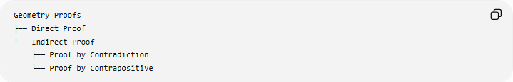
Geometry Proofs
├── Direct Proof
└── Indirect Proof
├── Proof by Contradiction
└── Proof by Contrapositive

1. Geometry Direct Proof

Definition
# Source: AI Source: Provided by: [Data Path: Persons Table -> ID Column: 1, Name_En Column: Motasem Essam] -> From: [ChatGPT] on [7/25/2026]
A Geometry Direct Proof establishes the desired conclusion by starting with the given information and proceeding through a logical sequence of definitions, postulates, theorems, and previously established facts until the conclusion is reached.
The proof does not begin by assuming that the conclusion is false.
$$\boxed{\text{Given}→\text{Known Facts}→\text{Logical Deductions}→\text{Conclusion}}$$

Simple Definition
# Source: AI Source: Provided by: [Data Path: Persons Table -> ID Column: 1, Name_En Column: Motasem Essam] -> From: [ChatGPT] on [7/25/2026]
Direct proof means:
Start with what is known and logically work forward until you prove what is required.

Basic Structure
# Source: AI Source: Provided by: [Data Path: Persons Table -> ID Column: 1, Name_En Column: Motasem Essam] -> From: [ChatGPT] on [7/25/2026]
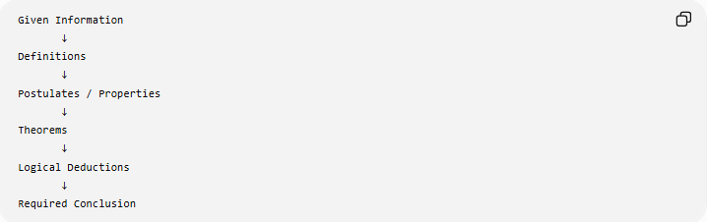
Given Information
↓
Definitions
↓
Postulates / Properties
↓
Theorems
↓
Logical Deductions
↓
Required Conclusion
Every step must be justified.

Example 1: Isosceles Triangle
# Source: AI Source: Provided by: [Data Path: Persons Table -> ID Column: 1, Name_En Column: Motasem Essam] -> From: [ChatGPT] on [7/25/2026]
Given
In $△ABC$:
$$AB=AC$$
Prove
$$∠B=∠C$$
Direct Proof
- $AB=AC$— Given.
- Therefore, $△ABC$is an isosceles triangle — Definition of an isosceles triangle.
- The angles opposite congruent sides of an isosceles triangle are congruent — Isosceles Triangle Theorem.
- Therefore:
$$\boxed{∠B=∠C}$$
The proof proceeds directly from the given side equality to the required angle equality.

Example 2: Vertical Angles
# Source: AI Source: Provided by: [Data Path: Persons Table -> ID Column: 1, Name_En Column: Motasem Essam] -> From: [ChatGPT] on [7/25/2026]
Given
Two lines intersect at $O$.
Prove
$$∠AOC=∠BOD$$
Direct Reasoning
Because $∠AOC$and $∠AOB$form a linear pair:
$$m∠AOC+m∠AOB={180}^{∘}$$
Similarly:
$$m∠BOD+m∠AOB={180}^{∘}$$
Therefore:
$$m∠AOC=m∠BOD$$
Hence:
$$\boxed{∠AOC≅∠BOD}$$
This is a direct proof because the desired result is derived from established angle relationships.

Example 3: Triangle Angle Sum
# Source: AI Source: Provided by: [Data Path: Persons Table -> ID Column: 1, Name_En Column: Motasem Essam] -> From: [ChatGPT] on [7/25/2026]
Given
$$∠A={50}^{∘} \\ ∠B={60}^{∘}$$
Find
$$∠C$$
Using the Triangle Sum Theorem:
$$A+B+C={180}^{∘}$$
Substitute:
$${50}^{∘}+{60}^{∘}+C={180}^{∘} \\ {110}^{∘}+C={180}^{∘}$$
Therefore:
$$\boxed{C={70}^{∘}}$$
Again, the reasoning moves directly from known information to the conclusion.

Advantages of Direct Proof
# Source: AI Source: Provided by: [Data Path: Persons Table -> ID Column: 1, Name_En Column: Motasem Essam] -> From: [ChatGPT] on [7/25/2026]
- Usually straightforward to follow.
- Makes the logical chain explicit.
- Often provides the shortest proof when the appropriate theorem is obvious.
- Clearly shows how the given information produces the conclusion.
- Commonly used in elementary and intermediate geometry.

2. Geometry Indirect Proof

Definition
# Source: AI Source: Provided by: [Data Path: Persons Table -> ID Column: 1, Name_En Column: Motasem Essam] -> From: [ChatGPT] on [7/25/2026]
A Geometry Indirect Proof establishes a conclusion without proving it directly from the given information.
Instead, the proof uses an alternative logical route.
Two major forms are:
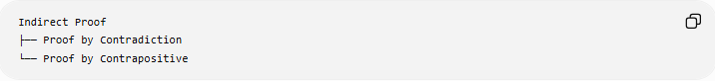
Indirect Proof
├── Proof by Contradiction
└── Proof by Contrapositive
The exact terminology can vary by textbook. Some texts use indirect proof primarily for contradiction, while others use it more broadly to include contrapositive reasoning.

A. Proof by Contradiction

Definition
# Source: AI Source: Provided by: [Data Path: Persons Table -> ID Column: 1, Name_En Column: Motasem Essam] -> From: [ChatGPT] on [7/25/2026]
Proof by Contradiction is an indirect proof in which the negation of the desired conclusion is temporarily assumed.
The assumption is then shown to produce a contradiction.
Therefore, the assumption must be false, and the original conclusion must be true.
$$\boxed{¬P→\text{Contradiction}→P}$$

Basic Structure
# Source: AI Source: Provided by: [Data Path: Persons Table -> ID Column: 1, Name_En Column: Motasem Essam] -> From: [ChatGPT] on [7/25/2026]
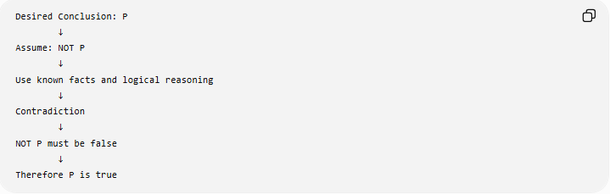
Desired Conclusion: P
↓
Assume: NOT P
↓
Use known facts and logical reasoning
↓
Contradiction
↓
NOT P must be false
↓
Therefore P is true

Example: Parallel Lines
# Source: AI Source: Provided by: [Data Path: Persons Table -> ID Column: 1, Name_En Column: Motasem Essam] -> From: [ChatGPT] on [7/25/2026]
Given
$$l_{1}⊥m$$
and
$$l_{2}⊥m$$
Prove
$$l_{1}∥l_{2}$$
Indirect Proof
We want to prove:
$$l_{1}∥l_{2}$$
Assume the opposite:
$$l_{1}∦l_{2}$$
Then the two lines would intersect.
But both $l_{1}$and $l_{2}$are perpendicular to $m$. In Euclidean geometry, through a given point there is a unique line perpendicular to a given line.
Therefore, the assumption that they are distinct intersecting lines both perpendicular to $m$creates a contradiction.
Thus:
$$\boxed{l_{1}∥l_{2}}$$

Example: Impossibility of a Triangle
# Source: AI Source: Provided by: [Data Path: Persons Table -> ID Column: 1, Name_En Column: Motasem Essam] -> From: [ChatGPT] on [7/25/2026]
Suppose someone claims that a triangle has:
$$A={100}^{∘}, B={90}^{∘}, C={20}^{∘}$$
Assume that such a triangle exists.
Its angle sum would have to be:
$${100}^{∘}+{90}^{∘}+{20}^{∘}={210}^{∘}$$
But every Euclidean triangle has:
$$A+B+C={180}^{∘}$$
Thus:
$${210}^{∘}≠{180}^{∘}$$
This is a contradiction.
Therefore, such a triangle cannot exist.
$$\boxed{\text{The proposed triangle is impossible.}}$$

B. Proof by Contrapositive

Definition
# Source: AI Source: Provided by: [Data Path: Persons Table -> ID Column: 1, Name_En Column: Motasem Essam] -> From: [ChatGPT] on [7/25/2026]
A Proof by Contrapositive establishes a conditional statement by proving its logically equivalent contrapositive.
For a statement:
$$P→Q$$
the contrapositive is:
$$\boxed{¬Q→¬P}$$
The original statement and its contrapositive are logically equivalent:
$$\boxed{P→Q ⟺ ¬Q→¬P}$$

Example
# Source: AI Source: Provided by: [Data Path: Persons Table -> ID Column: 1, Name_En Column: Motasem Essam] -> From: [ChatGPT] on [7/25/2026]
Consider the geometric statement:
If a triangle is equilateral, then it is isosceles.
Let:
$$P=\text{triangle is equilateral} \\ Q=\text{triangle is isosceles}$$
The original statement is:
$$P→Q$$
The contrapositive is:
$$¬Q→¬P$$
which means:
If a triangle is not isosceles, then it is not equilateral.
Reasoning
If a triangle is not isosceles, it does not have the required equal-side structure of an equilateral triangle.
Therefore:
$$\boxed{\text{not isosceles}→\text{not equilateral}}$$
Since this is the contrapositive of the original statement, the original conditional is established.

Direct Proof vs. Indirect Proof
# Source: AI Source: Provided by: [Data Path: Persons Table -> ID Column: 1, Name_En Column: Motasem Essam] -> From: [ChatGPT] on [7/25/2026]
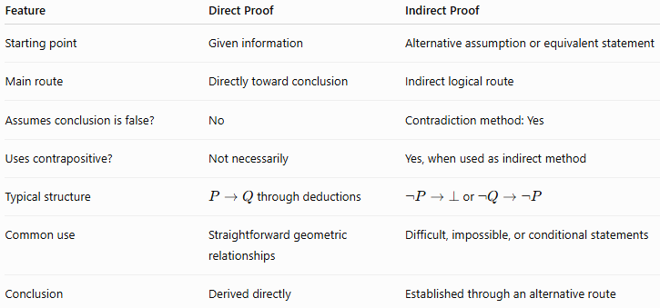
Feature | Direct Proof | Indirect Proof
Starting point | Given information | Alternative assumption or equivalent statement
Main route | Directly toward conclusion | Indirect logical route
Assumes conclusion is false? | No | Contradiction method: Yes
Uses contrapositive? | Not necessarily | Yes, when used as indirect method
Typical structure | $P→Q$through deductions | $¬P→⊥$or $¬Q→¬P$
Common use | Straightforward geometric relationships | Difficult, impossible, or conditional statements
Conclusion | Derived directly | Established through an alternative route

Detailed Structural Comparison
Direct Proof
$$\boxed{\text{Given}→A→B→C→\text{Conclusion}}$$
Example
$$AB=AC \\ ⇓$$
Isosceles triangle
$$⇓$$
Base angles congruent
$$⇓ \\ \boxed{∠B=∠C}$$

Indirect Proof by Contradiction
$$\boxed{\text{Conclusion}→\text{Assume opposite}→A→B→⊥→\text{Conclusion}}$$
Example
$$\text{Want }l_{1}∥l_{2} \\ ⇓$$
Assume:
$$l_{1}∦l_{2} \\ ⇓$$
They intersect
$$⇓$$
Contradiction with the perpendicular-line condition
$$⇓ \\ \boxed{l_{1}∥l_{2}}$$

Direct vs. Indirect Proof by Contrapositive
There is an important logical distinction.
Suppose the statement is:
$$P→Q$$
Direct approach
Assume $P$, then derive $Q$:
$$\boxed{P→Q}$$
Contrapositive approach
Assume $¬Q$, then derive $¬P$:
$$\boxed{¬Q→¬P}$$
Both establish the same conditional because:
$$\boxed{P→Q ⟺ ¬Q→¬P}$$

When to Use Each Approach

Direct Proof is useful when:
# Source: AI Source: Provided by: [Data Path: Persons Table -> ID Column: 1, Name_En Column: Motasem Essam] -> From: [ChatGPT] on [7/25/2026]
- the given information naturally leads to the conclusion;
- a relevant theorem is immediately available;
- the geometric relationships are straightforward;
- the proof can be completed with a short logical chain.
Example
Given:
$$AB=AC$$
and required:
$$∠B=∠C$$
The Isosceles Triangle Theorem provides a direct route.

Indirect Proof is useful when:
# Source: AI Source: Provided by: [Data Path: Persons Table -> ID Column: 1, Name_En Column: Motasem Essam] -> From: [ChatGPT] on [7/25/2026]
- directly proving the statement is difficult;
- assuming the opposite creates an obvious contradiction;
- the statement has a useful contrapositive;
- the problem involves impossibility or uniqueness;
- the negation of the desired conclusion gives stronger information.

Relationship to Other Geometry Proof Methods
# Source: AI Source: Provided by: [Data Path: Persons Table -> ID Column: 1, Name_En Column: Motasem Essam] -> From: [ChatGPT] on [7/25/2026]
Direct and indirect proofs describe logical approaches, while other classifications describe the mathematical tools or presentation formats used in a proof.
Logical Approaches
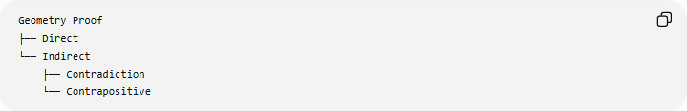
Geometry Proof
├── Direct
└── Indirect
├── Contradiction
└── Contrapositive
Geometric Frameworks
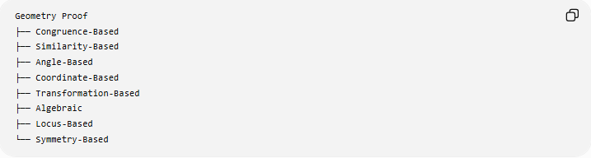
Geometry Proof
├── Congruence-Based
├── Similarity-Based
├── Angle-Based
├── Coordinate-Based
├── Transformation-Based
├── Algebraic
├── Locus-Based
└── Symmetry-Based
Presentation Formats
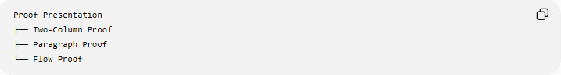
Proof Presentation
├── Two-Column Proof
├── Paragraph Proof
└── Flow Proof
These classifications can overlap.
For example:
A proof can be a direct proof, use triangle congruence, and be presented as a two-column proof.
Or:
A proof can be an indirect proof by contradiction, use angle relationships, and be presented as a paragraph proof.

Complete Classification
# Source: AI Source: Provided by: [Data Path: Persons Table -> ID Column: 1, Name_En Column: Motasem Essam] -> From: [ChatGPT] on [7/25/2026]
$$\boxed{\text{Geometry Proofs}}$$
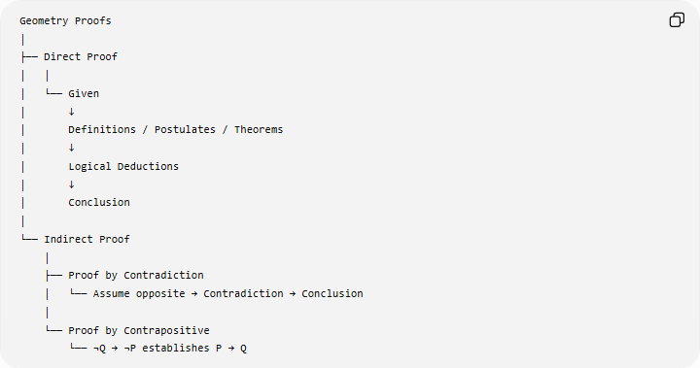
Geometry Proofs
│
├── Direct Proof
│ │
│ └── Given
│ ↓
│ Definitions / Postulates / Theorems
│ ↓
│ Logical Deductions
│ ↓
│ Conclusion
│
└── Indirect Proof
│
├── Proof by Contradiction
│ └── Assume opposite → Contradiction → Conclusion
│
└── Proof by Contrapositive
└── ¬Q → ¬P establishes P → Q

Key Points
# Source: AI Source: Provided by: [Data Path: Persons Table -> ID Column: 1, Name_En Column: Motasem Essam] -> From: [ChatGPT] on [7/25/2026]
- Direct Proof proceeds directly from the given information to the required conclusion.
- Indirect Proof reaches the conclusion through an alternative logical route.
- Proof by Contradiction assumes the desired conclusion is false and derives an impossibility.
- Proof by Contrapositive proves $P→Q$by proving $¬Q→¬P$.
- A direct proof does not need to assume the conclusion or its negation.
- Both direct and indirect proofs are deductive methods.
- A proof can combine these approaches with congruence, similarity, coordinates, transformations, algebra, and other geometric tools.
- Two-column, paragraph, and flow proofs are presentation formats, not alternatives to direct/indirect logical reasoning.
- A successful diagram or measurement does not by itself constitute a direct or indirect proof.
- The purpose of either approach is to establish that the conclusion follows necessarily from the assumptions.

Conclusion
# Source: AI Source: Provided by: [Data Path: Persons Table -> ID Column: 1, Name_En Column: Motasem Essam] -> From: [ChatGPT] on [7/25/2026]
Geometry Direct Proof and Geometry Indirect Proof are two fundamental approaches to geometric proof.
$$\boxed{\text{Direct Proof}=\text{Given}→\text{Logical Deductions}→\text{Conclusion}}$$
while:
$$\boxed{\text{Indirect Proof}=\text{Alternative Logical Route}→\text{Conclusion}}$$
The two principal forms of indirect proof are:
$$\boxed{\text{Proof by Contradiction}}$$
and
$$\boxed{\text{Proof by Contrapositive}}$$
Together, they give geometry students multiple logically valid ways to establish geometric statements.

